High Power Fiber Laser

Yb-doped fiber
Laser Output
High R. FBG
⎪⎪⎪⎪

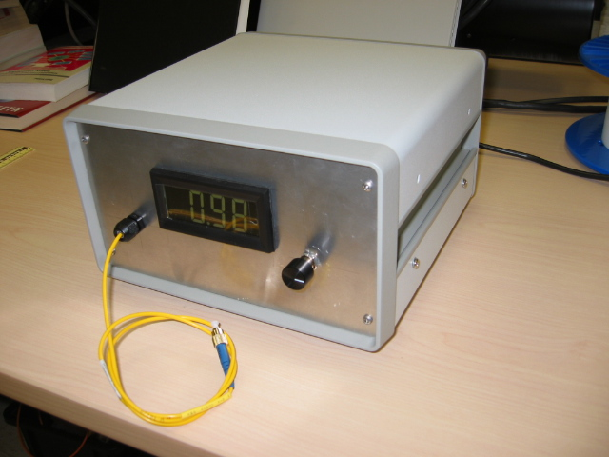

Packaged Fiber Laser (10” x 10” x 6”)

Fiber Sensor Arrays for Strain and Temperature Measurements

Fiber Bragg Gratings for Fiber Lasers

